**Ex.No : 1**

**Date : 10/10/2020**

**Aim:**

To write a python program to validate year and month, to display calendar of the given year and monthif its validelse print it as “Invalid Input”.

**Program:**

import calendar as cal

year=int(input("Enter the year : "))

month=int(input("Enter the month : "))

if(year>999 and year<10000):

if(month>=1 and month<=12):

print(cal.month(year,month))

else:

print("Invalid Input")

else:

print("Invalid Input")

**Output:**

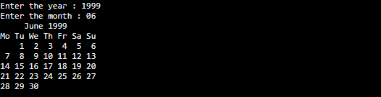





**Result:**

Thus, the program iscreated to validate year & month and output is obtained.